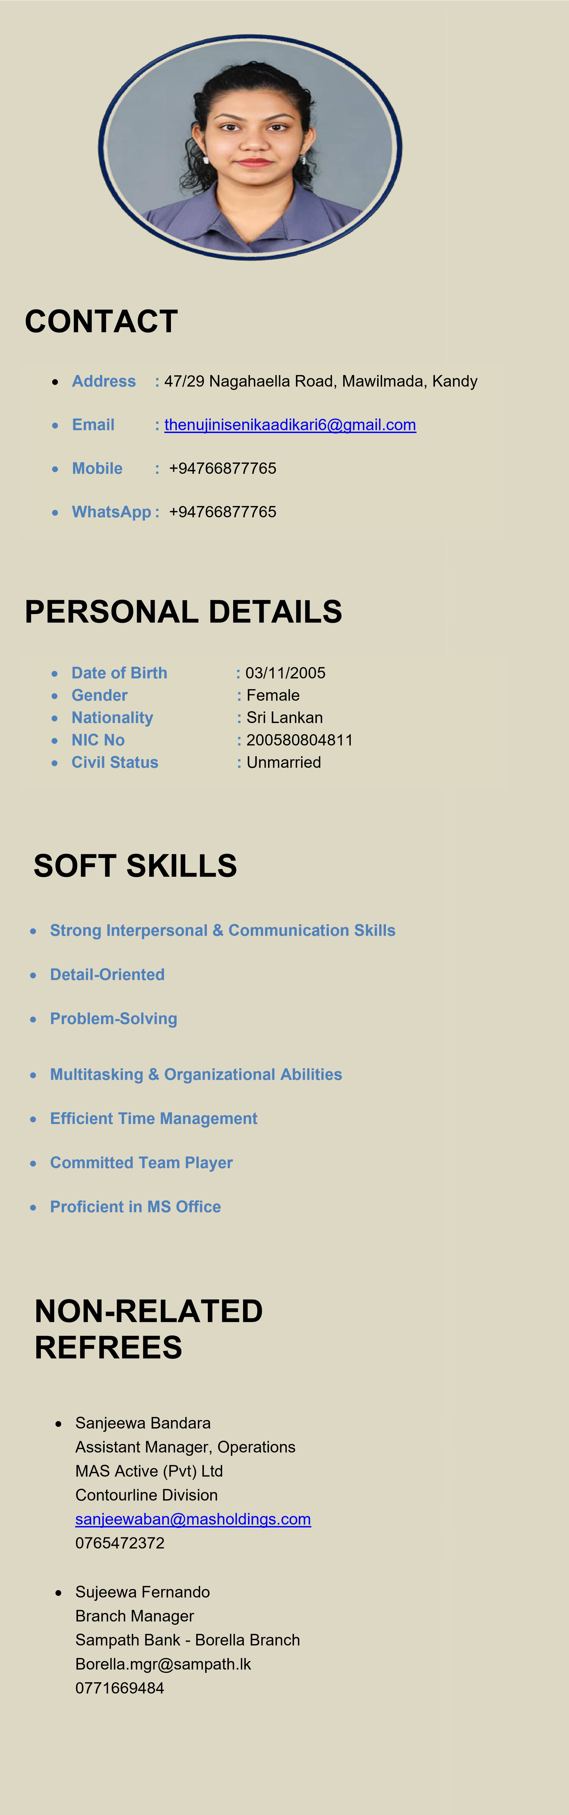
THENUJI NISENIKA ADIKARI

PROFILE SUMMARY
A motivated, responsible, and enthusiastic IT professional with a Higher Diploma in Software Engineering and an International Diploma in Information Technology. Possess a strong interest in software development, information technology, and emerging technologies, with good problem-solving, communication, teamwork, and organizational skills. A quick learner who is adaptable, dependable, and able to work effectively both independently and as part of a team. Seeking an opportunity in the IT and software industry where I can apply my technical knowledge, gain practical experience, develop my professional skills, and contribute positively to the success of the organization.

ACADEMIC & PROFESSIONAL QUALIFICATION

- Higher Diploma in Software Engineering
ICBT Kandy Campus (Expected to finish - 2026)
- Diploma In English
ESoft Metro Campus, Kandy (2025)
- Diploma in Business Management ESOFT Metro Campus (2022 -2024)

Gained expertise in business operations, communication, and organizational behavior. Developed key skills in time management, customer relationship management, data analytics, and business administration, essential for administrative and support roles.

- International Diploma in Information & Communication Technology
(OTHM) ICBT Campus, Kandy (2023)
Gained expertise in Microsoft Office Suite (Word, Excel, PowerPoint, Outlook), computer systems, web development, graphic design, programming, and computational mathematics, with a focus on technical problem-solving and data organization.

- Cambridge English A2 Key KET (2018)
Cambridge English A2 Key (KET) is a certification that assesses fundamental English skills in reading, writing, listening, and speaking, designed for individuals who can communicate in simple, everyday contexts at the A2 level of the CEFR.

EDUCATIONAL QUALIFICATIONS

• G.C.E Advanced Level Examination (English Medium) 2024
Sussex College, Polgolla - 13594087

• G.C.E Ordinary Level Examination (English Medium) 2021
Sussex College, Polgolla – 33944089

EXTRACURRICULAR ACTIVITIES

• Member of School Dancing Troupe
Actively participated in traditional and contemporary dance performances at cultural events, showcasing creativity and teamwork.

• Member of School Western Band
Contributed to musical performances, enhancing group dynamics and discipline while performing at school events and competitions.

• Girl Guide (Senior Guide)
Developed leadership and community service skills through Girl Guide activities, including organizing camps, leading team projects, and national events.

• Wing Attacker in School Netball Team
Competed as part of the school netball team, emphasizing teamwork, strategic thinking and physical fitness

• Member of School English Society
Engaged in literary discussions, poetry readings and writing workshops.
Fostering language skills while contributing to the school's literary magazine.

• Member of School Media Club
Participated in media-related activities including content creation, event coverage, and communication initiatives within the school.

